Fruit 20 -30 min before boot camp (pineapples or melons are great)
MEN | WOMAN
Meal 1 (breakfast)  6 egg whites, or Egg Beaters  4 oz. turkey breast  2 slices of whole wheat bread | Meal 1 (breakfast)  3-4 egg whites, 1 yolk  2 oz. turkey breast  1 slice of whole wheat bread
Meal 2 (snack)  Protein drink | Meal 2 (snack)  Protein drink (Syntha-6 is good)
Meal 3 (lunch)  2 cups salad  1 tbs. sunflower oil  1 tbs. balsamic vinegar  8 ounces lean Protein (chicken or fish)  1 medium carrot | Meal 3 (lunch)  1.5 cups salad  2 tsp. sunflower oil  1 tbs. balsamic vinegar  4 oz. lean Protein (chicken or fish)  1 small carrot
Meal 4 (snack)  Greek yogurt or  Protein shake with fruit | Meal 4 (snack)  Greek yogurt or  Protein shake with fruit
Meal 5 ( dinner)  1.5 cups steamed vegetables  8 oz. lean protein of choice | Meal 5 (dinner)  1 cup steamed vegetables  5 oz. lean protein of choice
"Carb-Load" Meal Every Third Day 1.5 cups cooked brown rice  1 cup steamed vegetables  1 tbs. sesame oil  1 large yam (baked)  1 medium banana (dessert) | "Carb-Load" Meal Every Third Day  1 cup cooked brown rice  1 cup steamed vegetables  2 tsp. sesame oil  1 small yam (baked)  1 small banana (dessert)

(ONE Free Meal or Cheat Meal per week)
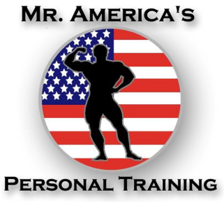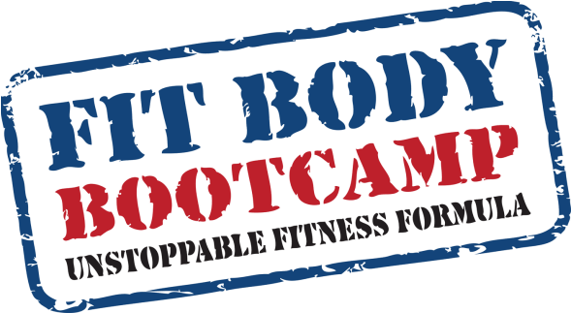

MrAmericasPersonalTraining.com
&
NewYorkFitBodyBootCamp.com

